Rocket Pi Cam Recorder Manual

**Description:**

The device in its entirety consists of:

Raspberry Pi Zero; PiCam with its ribbony cable; power unit that connects to RPI with a header; battery; circuit board that connects to RPI with a header over a cable

This device will start recording on start up (due to connection of battery/power) and will end recording once the button is pressed or a low battery warning is given by the power unit connected on the Raspberry Pi header. Recording is indicated by the LED when it is lit up. In both cases of button press or low battery warning from the power unit, the device will halt the operating system and the battery can be disconnected to power off the device.

All videos will be recorded in the directory /launch_videos. The videos use a numbering scheme where a lower number is an earlier recording and a higher number means a later recording.

**Usage:**

Make sure you got the SD Card inserted properly into the SD Port on the RPI.

Ensure the power unit (without the battery being connected!) is connected to the RPI headers. It should be attached such that if the RPI is oriented so that the headers are on top and facing you, the power unit should be attached to the right-most pins with the battery port facing rightward.

Ensure the Pi Camera is connected into the correct port. The camera should be connected such that the lens is facing upward if the cable is not twisted.

Attach the circuit board cable to the RPI Zero. It should be attached so that if the RPI is oriented such that the RPI headers are facing you and are on top, cable will be connected to the header one row of pins away from the power unit. The cable orientation should have the side with the 3 connections facing you and the side with only 1 connection in the middle facing away from you.

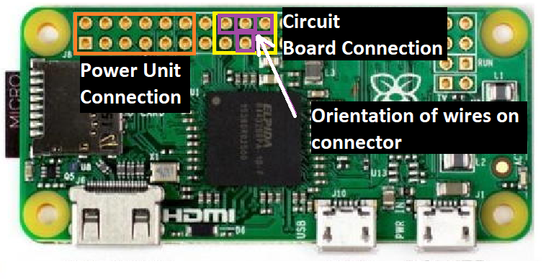

Now you can power up the RPI by attaching the battery to the power unit. Recording will start when the LED on the circuit board lights up.

When recording is finished, press the button on the circuit board to stop recording. The LED on the circuit board should turn off soon after. Wait for the green LED to be off for at least 20 seconds before disconnecting the battery to finally power off. It can take a while (~40 seconds max) before the green LED finally turns off.

If you simply want to turn off the RPI, you will have to follow the above instruction for when recording is finished so that the operating system and existing videos don’t get corrupted by disconnecting the battery too early.

When you want to transfer the files to a Windows computer, know that the files are in raw .h264 encoding instead of standard .mp4 format. You will have to convert it for most players to accept the file. The framerate is 25 frames/sec which many converters will need. If you do not have a .h264 to .mp4 converter, this can be done on the RPI using the instructions found in the problem stuff section below. Once that is done you can transfer the .mp4 videos to your computer.

There are two ways to transfer files to a computer. One way is to use SSH file transfer over USB using a program called psftp.exe (this program is for Win10). You should have this program if you installed the Putty SSH client on your computer. The second way is to take out the SD card from the RPI and use a program called Ext2Explore in order to read the Linux filesystem on the SD card.

**To SSH over USB using psftp on Win10 (you will need a micro-USB to normal USB cable):**

First, open Control Panel, go to Network and Sharing Center -> Change Adapter Settings (on the left pane). Leave it open as you will need to keep track of any new adapters that appear. Get a micro-USB cable and plug it into the micro-USB port labeled USB on the RPI. You do not need the power unit and the battery as the RPI can be powered over USB. Now plug the other end of the cable into your computer. Wait for a new ethernet adapter to appear on your Control Panel screen. Now change your static IP address to 192.168.137.1 on your new adapter. If you have no idea what this means, follow the steps after. Once you set the static IP you can go to the text after the paragraph below which explains PSFTP.

To set the static IP: Right click on the new ethernet adapter in the window opened above and go to Properties. In the Networking tab, select Internet Protocol Version 4 (TCP/IPv4). Click on the Properties button. Select the Use the following IP address button. In the IP Address Box, enter 192.168.137.1. In the subnet mask box, enter 255.255.255.0. You can ignore the other settings and click Ok to exit. Click Ok on the Properties box you opened before again.

**To use PSFTP:**

Open PSFTP. Enter open 192.168.137.24 (this is the RPIs IP address on your mini network). If it asks for username and password, enter pi for username and raspberry for password. Now you can use the cd command to navigate to /launch_videos on the RPI (or another directory if you want to download or upload somewhere else).

Example of cd command to navigate to /launch_videos:

cd /launch_videos

To print the directory you are currently in on YOUR computer, use the lpwd command. This is where saves will happen on your PC. To change the directory on your computer, use the lcd command. To view contents of the folder you are in on the RPI, use dir command. Finally, to download, use the get command. Its used as follows:

get [File on RPI to download] [name of file after download on your computer (optional)]

If you want to upload any files, use the put command:

put [name of file on your computer] [name of uploaded file on RPI (optional)]

**To use SSH with Putty:**

Make sure you followed the paragraph under “To SSH over USB using psftp on Win10:”. You do not need to follow the steps in “To use PSFTP:”.Just use Putty as normal, with the IP address being 192.168.137.24. The username and password is pi and raspberry.

**To use Ext2Explore over SD card (install Ext2Explore first):**

Turn off the RPI first, which means safely shutting down if possible and removing power. Take the micro SD from the RPI and find a way to connect it to the PC. This is usually done with a micro SD to normal SD adapter. Once it is in, you may find your computer complains a lot. Close the warnings, and please do not format anything! Find Ext2Explore and run it as administrator. The SD directory should appear. If it doesn’t, go to File -> Rescan System. Now you can navigate to /launch_videos, and then select the files you need and go to Tools -> Save to transfer the files.

If the SD card does not appear still, its likely a problem with your computer or the SD adapter.

(In my case that this happened, I kind of cleaned the micro SD to SD adapter pads and the micro SD card pads. I then pushed the micro SD harder than normal into the adapter.)

**Debugging and Problem Stuff:**

Make sure everything is connected properly before trying to do any of the below steps.

If you are trying to shut off the RPI and the green light isn’t turning off, try pressing the button again. If it takes over 10 minutes to shut off the RPI, wait for when the green light isn’t flashing too much and then disconnect battery/power. This gives it the best chance of preserving most if not all the data. (I’ve done it before and usually the memory does not get corrupted.)

If you see the device has its recording LED off and the RPI has its green LED also off, it means the system has powered off and you should disconnect the battery/power. If you don’t know what caused the system to power off, its likely that the power unit sent a shutdown signal to the RPI. This is probably due to low battery.

If you need to interact with the operating system, you can do so by using SSH with the program Putty. To do this, follow the instructions above labeled “To use SSH with Putty:”

To convert the .h264 to .mp4 on the RPI, follow the above instructions labeled “To use SSH with Putty:” to open the Linux terminal. Navigate to the folder /launch_videos using the cd command. Then use the following command:

MP4Box -fps 25 -add [name of raw .h264 video] [name of new .mp4 video].mp4

You may want to start and stop the recording service in the OS. To start the service, type in the terminal:

sudo systemctl start RocketPiCam

To stop the recording service:

sudo systemctl stop RocketPiCam

If you want to be cool and shut off the RPI from the terminal, type in:

sudo poweroff

or

sudo shutdown -h now

Once the green light remains off for atleast 20 seconds, you can now disconnect the power from the RPI.

Happy flying! 😊